**SEVERAL TASKS CASCADED INTELLIGENT FRUIT RECOGNITION USING MULTI-TASK CASCADED CONVOLUTIONAL NETWORKS FOR CREATING AUTOMATION ROBOTS**

*1T.Srividhya , 2**A.Manohitha ,3 P.Nandini, 4K.Vamshidhar,*5 *Mr N.Shiva Prasad*

# *1,2,3,4bachelor Degree, Cse,* *Jayamukhi Institute Of Technological Sciences Narsampet, Warangal.*

*5Mr N.Shiva Prasad, Assistant Professor, Professor, bachelor Degree, Cse, Jayamukhi Institute Of Technological Sciences Narsampet, Warangal.*

**ABSTRACT:**

Designing an automated robot (AuRo) for fruit identification is deemed essential for yield estimation, disease management, harvesting, sorting, and grading. Over the past few decades, a number of fruit identification algorithms for developing AuRo have been created. However, real-time reaction, accuracy, and flexibility are weaknesses of standard fruit detecting systems. This study suggests an enhanced intelligent fruit identification (InFD) approach based on multi-task cascaded convolutional networks (MTCNN). The AuRo can function in real-time and with great precision using this technique. Additionally, this study proposes an enhanced augmented strategy based on the link between the number of samples for the dataset and the parameters of neural networks evolution. a method to enhance the performance of the detector based on picture fusion. . The results of the trial showed that the suggested detector operated flawlessly in terms of accuracy and efficiency. The lengthy experiment also showed that the suggested approach may easily function with other similar items and has high portability.

**INTRODUCTION:**

Over the past few decades, fruit detection for applications such as yield prediction, grade sorting, disease prevention, and other agricultural fields has shown significant growth [1]–[5]. Automated harvesting robots have been used in a number of systems, which has significantly improved the sector [6], [7]. One of the most popular study areas, drawing the majority of agricultural businesses, has been the identification and classification of fruits according to their quality. Fruit detection is unquestionably the most important factor to take into account while conducting in-depth research on the topic. As a result, several academics have been working for a long time to create reliable algorithms for fruit detection [8]–[10]. Fruit detection systems' performance has significantly increased, but they are still not ready for widespread use. The unstable and uncontrolled settings of orchards are the main challenges in constructing such a fruit detecting system. These include a wide range of difficult jobs, including poor or excessive lighting, blurry backdrops, significant occlusion from nearby berries or other flora, low resolution, position fluctuation, and more.

Fruit identification may be viewed as a unique class of object detection that has many characteristics with tasks involving face detection [11]–[13]. Cascaded convolutional networks (CCN)-based face identification has made a notable advancement due to the benefit of high accuracy [14], [15]. Due to its exceptional accuracy and efficiency, multi-task cascaded convolutional network (MTCNN) [16] is the most popular of these cutting-edge techniques.

MTCNN has made significant progress in the face identification challenge, however using this technique straight to the fruit detection job is not appropriate. Because of how MTCNN was designed, its architecture has several specificity features for face identification that are inappropriate for the job of fruit detection. Therefore, eliminating customised functionality from this MTCNN framework is necessary to enhance it.

Another significant obstacle to fruit recognition is the lack of a common baseline. A significant number of sample photos is crucial for the training of deep learning-based models. For this study, we used a digital camera to gather pictures from an apple orchard. Then, in order to construct a dataset, we chose the appropriate ones and labelled them. It takes time and effort to create a dataset by hand.

Therefore, based on the fusion algorithm, we developed a new enhanced technique. This fusion approach was inspired by the idea that newly generated samples should closely resemble real pictures. Fusion photos were used to provide more samples for diversity, which would assist this detector produce better results in the end. We trained the detector on two other fruit species (strawberry and orange) in order to assess the structure's suitability for use with other types of items.

Our contributions are, in brief, as follows:

1. By enhancing the MTCNN baseline model, we suggested Fruit-MTCNN (F-MTCNN), a novel architecture for fruit detection. Additionally, this detector has low time consumption and good accuracy.

2. We put forth fusion augmentation (FA), a brand-new enhanced technique. We create fake picture samples by randomly cropping dataset samples and adding negative patches to increase the variety of the samples.

3. The suggested method only requires a modest number of training samples and is easily transferable to various types of objects.

The remaining portions of the paper are organised as follows. We examine earlier related work on fruit detection in Section II. We describe the methodology for this investigation in Sections III and IV. Section V of this report presents the results of our tests. The analysis and discussion of our findings as well as the work's conclusion are presented in Section VI.

**RELETED WORK:**

L[1]: Surface defect identification in mangosteens utilising convolutional neural network application of deep learning.

Authors: Cahya Damarjat, Sitti Fadillah Umayah, Laila Ma'rifatul Azizah, Slamet Riyadi, and Nafi Ananda Utama

Description: One fruit with a significant export potential in Indonesia is mangosteen. However, not every mangosteen is a fruit without flaws. Mangosteen export quality control is carried out manually by skilled sorters. As a result, the outcomes may be unreliable and erroneous. Human mistake is the cause of the outcome. To aid in the process of separating out the defects from the non-defects, image processing technology is required. Convolutional Neural Networks (CNN), one of the deep learning architectures, are used in this study.

As a result, we employ CCN to identify mangosteen. When it comes to picture classification, CNN has shown to be quite effective. Utilising 4-folds Validation Cross, the CNN technique verifies the correctness of the data. Initialising the parameter setup speeds up network training while creating the CNN architecture model. The outcomes of the trials employing the CNN algorithm demonstrated a 97% accuracy rate for fault identification on mangosteen fruit.

L[2]: Grading of red banana ripening stages using changes in dielectric characteristics and an image-processing method

Asutosh Mohapatra, S. Shanmugasundaram, and R. Malmathanraj are the authors.

In this study, red banana fruit's dielectric characteristics are examined at various ripening temperatures in order to provide a quick and non-destructive method for determining the stages of ripeness. The dielectric characteristics that are altered by the placement of a red banana in between the plates are measured using a rectangular parallel plate capacitor circuit and a 5 volt sine wave AC power source. . While impedance and admittance steadily drop with an increase in the red banana's ripening stages, the values of characteristics like capacitance and relative permittivity constantly rise. To determine the level of ripeness of red bananas, image processing approaches based on Noise Reductant Local Binary Pattern (NRLBP), Local Binary Pattern (LBP), and Completed Local Binary Pattern (CLBP) are utilised. The processing steps include categorization, Binary Pattern creation, and improvement. The results of testing the variant Binary patterns in noisy and noiseless conditions are compared.

. Based on segmentation employing Tsallis entropy, a novel improvement approach for banana ripening grade determination is suggested. Additionally, a unique method for automating the q parameter used in Tsallis entropy is put into practise. The Noise Reductant Local Binary Pattern's (NRLBP) threshold parameter was changed, and the classification rate was examined as a result. To accommodate a uniform backdrop and sections with the picture, a new modification is suggested and put into place on NRLBP. Fuzzy C means (FCM) clustering and Chi-Square distance/nearest neighbour analysis are used for classification. The advantage of the FCM approach for determining banana ripening grade is noticed after a comparison of the findings.

An automated technique for diagnosing wheat disease in the field.

Jiang Lu, Jie Hu, Guannan Zhao, Fenghua Mei, and Changshui Zhang are the authors.

Description: Crop diseases are to blame for the significant decline in productivity and financial losses in the global agriculture sector. In order to prevent the spread of diseases and perform efficient management, crop health monitoring is essential. This study describes an in-field automatic diagnosis system for wheat diseases based on weakly supervised deep learning, or deep multiple instance learning, which integrates disease localization and disease identification using only image-level annotation for training images under natural conditions.

In order to confirm the efficacy of our method, a fresh in-field picture dataset for wheat disease called Wheat Disease Database 2017 (WDD2017) is gathered. Our system outperforms two conventional CNN frameworks, namely VGG-CNN-VD16 and VGG-CNN-S, which achieved mean recognition accuracies of 93.27% and 73.00% over 5-fold cross-validation on WDD2017. These results were obtained under two different architectures, namely VGG-FCN-VD16 and VGG-FCN-S. The suggested approach outperforms traditional CNN architectures on recognition accuracy under the same number of parameters, according to experimental findings, while preserving accurate localisation for the respective illness regions. Additionally, the suggested method has been integrated into a live mobile app to enable the identification of agricultural diseases.

L[4]: Colour information and region-growing are used to segment photos of greenhouse vegetable foliar disease spots.

Authors: Feixiang Zheng, Jinxiang Chu, Lingxian Zhang, Juncheng Ma, Keming Du, and Zhongfu Sun

This study proposes a brand-new technique for segmenting greenhouse vegetable foliar disease spots in photos taken in the field utilising colour information and region growth. Uneven lighting and a complex background plague illness photos taken in real-world field settings, making it difficult to divide disease patches accurately.

The segmentation of illness spots using two pipelined processes is suggested in this work. In the beginning, a thorough colour feature and its detection technique are introduced. The Excess Red Index (ExR), the H component of the HSV colour space, and the b component of the Lab colour space are the three colour components that make up the complete colour feature (CCF), which provides robust differentiation of disease spots and cluttered backdrop. Then, to achieve illness spots separation from clutter backdrop, an interactive region expanding approach based on the CCF map is applied. Cucumber downy mildew photos are used to test the suggested segmentation method's accuracy and resilience. Results indicate that the suggested strategy may produce accurate and reliable segmentation in actual field settings.

L[5]: A reliable method for grape cluster segmentation based on colour characteristics.

Mohammad Reza Maleki and Nasser Behroozi-Khazaei are the authors.

Description: In modern agriculture, image processing has been extensively employed for automation. The most contentious and difficult problem that researchers face in an orchard environment is the algorithm creation for picture segmentation. This research offers a robust system for segmenting grape clusters from leaves and background using colour cues close to harvest. The algorithm is based on artificial neural network (ANN) and genetic algorithm (GA). GA was used to concurrently choose the best colour characteristics and optimise the ANN structure.

The outcomes demonstrated that GA defines 8-15-35-3 as the optimal ANN structure and identifies the 8 colour attributes as supreme features. The algorithm's total accuracy was 99.40%. The study's encouraging algorithm development findings have paved the way for its introduction as a useful sensing tool for precision agriculture and businesses that deal with picture analysis.

L[6]: Apple Harvesting Robot Apple Location Method

Wenhua Mao, Baoping Ji, Jicheng Zhan, Xiaochao Zhang, and Xiaoan Hu are the authors.

The apple harvesting robot should have two eyes to detect where apples need to be picked. Instead of using digital video as is customary, the binocular machine vision system was created using two Canon digital cameras. As a result, the digital camera vision system outperformed the digital video vision system in terms of performance and resolution. It could take JPEG images with a resolution of 3456*2592 pixels, and its field of view included the whole apple tree. With ripe fruits and their surrounds of leaves and branches, there is a clear colour difference for the Fuji apple tree. Therefore, apples were separated from their surroundings using the Drg-Drb colour index.

. After that, the area filter removed the incorrectly identified background regions, and the area parameter was used to choose the picking apples. Following that, the bidirectional scanning line algorithm, which was scanned in both the horizontal and vertical directions, was used to segment the conglutinated apples. Finally, the circum-diameter matching method was used to place all of the picking apples. According to the trial findings, 90% of apple fruit were correctly classified after they were picked.

L[7]: During postharvest processing, real-time segmentation of strawberry flesh and calyx using photos of singulated strawberries.

A. Durand-Petiteville, S. Vougioukas, and D.C. Slaughter are the authors.

This study proposes an image processing system that automatically separates strawberry photos' flesh and calyx regions. A camera built into a strawberry decapping machine takes pictures. Conditions that are characteristic of postharvest processing include regulated lighting and background knowledge. The objective is to remove as much flesh and calyx pixels as possible without excluding any background pixels. The suggested method starts with two-dimensional colour space picture colour segmentation, then moves on to blob identification and selection. To analyse the algorithm's sensitivity to user-defined parameters and assess the effectiveness of the method, 250 photos are employed.

. Despite inherent variance in strawberry form and appearance, the algorithm is simple to adjust and enables reliable extraction of the areas of interest. Less than 1% of the background pixels were inadvertently included while the algorithm effectively retrieved more than 98% of the flesh region. Moreover, with fewer than 0.25% incorrect background pixels, up to 79% of the calyx area could be retrieved. Finally, the algorithm has been created in real-time utilising the C++ and Cuda programming languages.

Based on a local binary pattern feature and a hierarchical contour analysis, L[8]: Immature citrus fruit identification.

Authors: Xiuwen Hu, Hao Gan, Won Suk Lee, and Jun Lu

Description: Prior to harvest, producers may predict their production and profit by detecting immature fruit in orchards and planning the administration of fertilisers. This work set out to create a reliable algorithm for identifying and counting immature citrus fruit in photographs of the tree canopy. All of the photos were shot with a torch in low light settings, and the green portion of the colour photos was used for additional analysis. Local intensity maxima were found, and local binary pattern (LBP) features were retrieved to use as an input for an ensemble classifier using RUSBoost.

The hierarchical contour maps around the affirmative predictions were recovered and fitted using the Circular Hough Transform, and they were taken into consideration as candidates. If the radius of the fitted circles fell within a certain range, they were projected to be fruit targets.

A test set of 25 photos was used to assess the method; it had an 80.4% true positive rate, an 82.3% accuracy rate, and an F-measure of 81.3%. The resilient LBP texture descriptor and hierarchical contour analysis (HCA), which employed the pattern of light intensity distribution on fruit surface, were the primary contributors to the proposed method's successful occlusion tolerance. This work offered a novel technique to identify green fruit in tree photos using simply texture and intensity distribution.

Better Cross-Label Suppression Dictionary Learning for Face Recognition, L[9]

Tian Zhou, Sujuan Yang, Lei Wang, Jiming Yao, and Guan Gui are the authors. The label property for signal representation in face recognition may be effectively preserved via cross-label suppression dictionary learning. The improved dictionary learning algorithm that is proposed in this paper for the face recognition problem takes into account the tradeoffs between operating time and signal reconstruction residuals and combines an ideal loss function with the cross-label suppression supervised dictionary learning approach. This study seeks to choose an ideal sparse coding dimension for the original signal to minimise the computational cost based on the link between the cost time of the dictionary learning method and the residuals of the sparse representations. Face recognition experiments.

**EXISTING SYSTEM:**

Automated harvesting robots have the potential to address numerous issues in agriculture, including the rapidly growing global elderly population, rising labour costs, rising crop demand, and others. The most crucial components of a harvesting robot's vision system are finding and accurately locating fruits. For this reason, fruit identification and detection have been the subject of years of in-depth research. According to the technology they use, these strategies may generally be categorised into three categories.

**PROPOSED SYSTEM:**

In comparison to earlier work, this multi-modal approach's performance is superior. However, it is insufficient to directly identify fruit utilising Faster RCNN architecture. This is because the detection job for numerous categories of objects with large scale change was developed using the Faster-RCNN. In contrast, the visual system in agriculture only needs to recognise one or a small number of different types of fruit, and often the size of the fruit does not alter substantially. As a result, using the FasterRCNN model for the job of fruit detection is difficult and time-consuming. Furthermore, because Faster-RCNN has a deeper architecture with thirteen convolution layers, it requires a significant quantity of data to avoid over-fitting issues. The accuracy of detection has greatly increased in recent years as a result of the fast growth of security, intelligent technology, and other applications.

**RESULT:**

****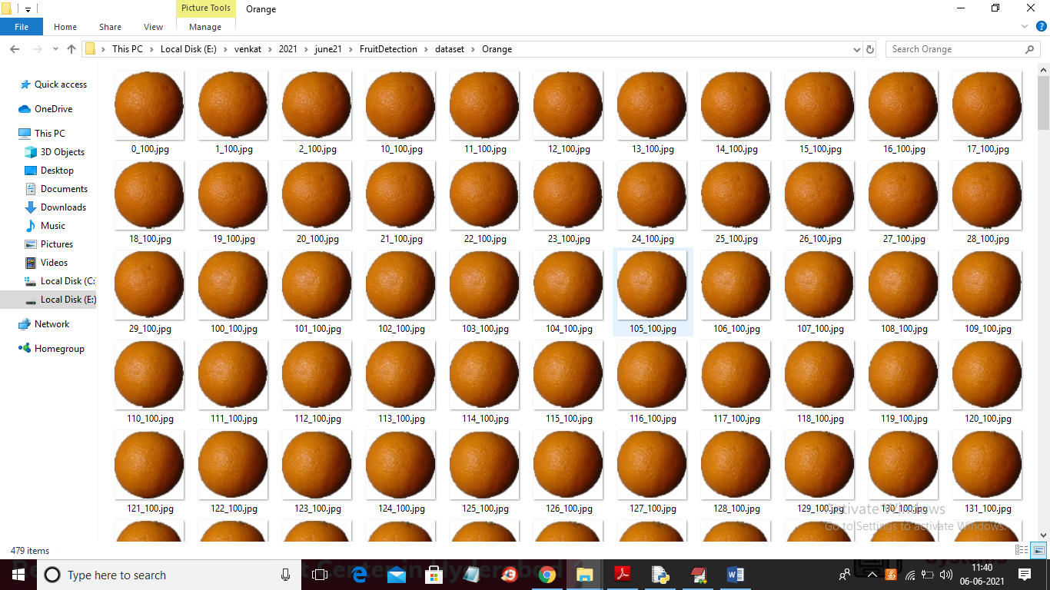

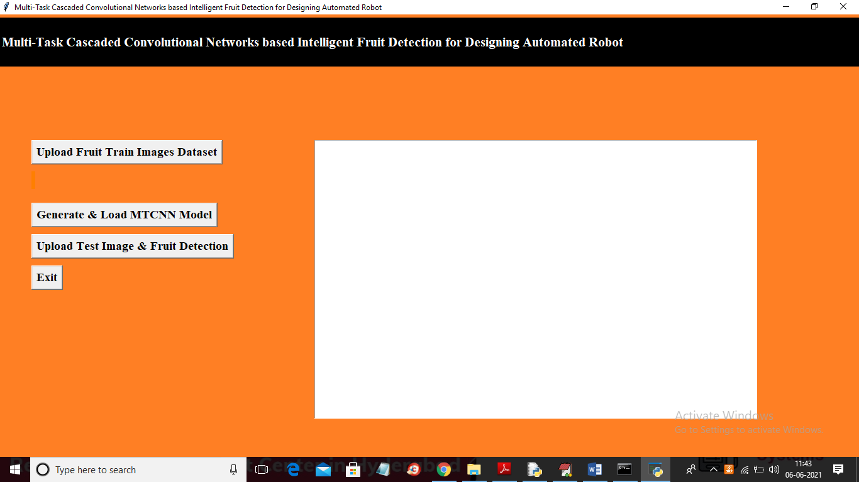



**CONCLUTION :**

In this study, fruit detection was accomplished using a multi-task cascaded convolutional network based detector. For our study, we selected apples, and we gathered and labelled more than a thousand pictures from apple orchards. In order to generate a dataset, we also added the right number of additional photographs from the internet and the ImageNet collection. In addition, we suggested fusion augmentation, a brand-new enhanced technique. The findings of the comparison trial showed that this increased strategy can enhance the end outcome. We chose the strawberry and orange as two more test fruits to see if the detector could be used with other varieties of fruit as well. The ImageNet collection, which includes hundreds of photos, served as the source for the training data.

Our findings shown that the detector is easily adaptable to other types of fruit as well. Finally, using twelve sets of photos with various resolutions, we tested the detector. Each set had 100 pictures. The detector's average reaction time was less than 80 seconds for every 100 photos, which is extremely close to real-time response.

**REFERENCES:**

[1] L. M. Azizah, S. F. Umayah, S. Riyadi, C. Damarjati, and N. A. Utama, ‘‘Deep learning implementation using convolutional neural network in mangosteen surface defect detection,’’ in Proc. 7th IEEE Int. Conf. Control Syst., Comput. Eng. (ICCSCE), Nov. 2017, pp. 242–246.

[2] A. Mohapatra, S. Shanmugasundaram, and R. Malmathanraj, ‘‘Grading of ripening stages of red banana using dielectric properties changes and image processing approach,’’ Comput. Electron. Agricult., vol. 143, no. 382, pp. 100–110, 2017.

[3] J. Lu, J. Hu, G. Zhao, F. Mei, and C. Zhang, ‘‘An in-field automatic wheat disease diagnosis system,’’ Comput. Electron. Agricult., vol. 142, pp. 369–379, Nov. 2017.

[4] J. Ma, K. Du, L. Zhang, F. Zheng, J. Chu, and Z. Sun, ‘‘A segmentation method for greenhouse vegetable foliar disease spots images using color information and region growing,’’ Comput. Electron. Agricult., vol. 142, pp. 110–117, Nov. 2017.

[5] N. Behroozi-Khazaei and M. R. Maleki, ‘‘A robust algorithm based on color features for grape cluster segmentation,’’ Comput. Electron. Agricult., vol. 142, pp. 41–49, Nov. 2017. [6] W. Mao, B. Ji, J. Zhan, X. Zhang, and X. Hu, ‘‘Apple location method for the apple harvesting robot,’’ in Proc. 2nd Int. Congr. Image Signal Process., Oct. 2009, pp. 1–5.

[7] A. Durand-Petiteville, S. Vougioukas, and D. C. Slaughter, ‘‘Real-time segmentation of strawberry flesh and calyx from images of singulated strawberries during postharvest processing,’’ Comput. Electron. Agricult., vol. 142, pp. 298–313, Nov. 2017.

[8] Y. Shi, W. Huang, J. Luo, L. Huang, and X. Zhou, ‘‘Detection and discrimination of pests and diseases in winter wheat based on spectral indices and kernel discriminant analysis,’’ Comput. Electron. Agricult., vol. 141, pp. 171–180, Sep. 2017.

[9] J. Lu, W. Suk, H. Gan, and X. Hu, ‘‘Immature citrus fruit detection based on local binary pattern feature and hierarchical contour analysis,’’ Biosyst. Eng., vol. 171, pp. 78–90, Jul. 2018.

[10] A. Gongal, S. Amatya, M. Karkee, Q. Zhang, and K. Lewis, ‘‘Sensors and systems for fruit detection and localization: A review,’’ Comput. Electron. Agricult., vol. 116, pp. 8–19, Aug. 2015.

[11] T. Zhou, S. Yang, L. Wang, J. Yao, and G. Gui, ‘‘Improved cross-label suppression dictionary learning for face recognition,’’ IEEE Access, vol. 6, no. 1, pp. 48716–48725, 2018.

[12] S. Liao, A. K. Jain, and S. Z. Li, ‘‘A fast and accurate unconstrained face detector,’’ IEEE Trans. Pattern Anal. Mach. Intell., vol. 38, no. 2, pp. 211–223, Feb. 2016.

[13] Y. Zheng, C. Zhu, K. Luu, C. Bhagavatula, T. H. N. Le, and M. Savvides, ‘‘Towards a deep learning framework for unconstrained face detection,’’ in Proc. IEEE Int. Conf. Biometrics Theory, Appl. Syst. (BTAS), Sep. 2016, pp. 1–8.

[14] K. Zhang, Z. Zhang, H. Wang, Z. Li, Y. Qiao, and W. Liu, ‘‘Detecting faces using inside cascaded contextual CNN,’’ in Proc. IEEE Int. Conf. Comput. Vis., Oct. 2017, pp. 3190–3198.

[15] Z. Yang and R. Nevatia, ‘‘A multi-scale cascade fully convolutional network face detector,’’ in Proc. 23rd Int. Conf. Pattern Recognit. (ICPR), Dec. 2016, pp. 633–638.

[16] K. Zhang, Z. Zhang, Z. Li, and Y. Qiao, ‘‘Joint face detection and alignment using multitask cascaded convolutional networks,’’ IEEE Signal Process. Lett., vol. 23, no. 10, pp. 1499–1503, Oct. 2016.

[17] W. Ji, X. Meng, Y. Tao, B. Xu, and D. Zhao, ‘‘Fast segmentation of colour apple image under all-weather natural conditions for vision recognition of picking robots,’’ Int. J. Adv. Robotic Syst., vol. 13, no. 1, pp. 1–24, 2016.

[18] H. Dang, J. Song, and Q. Guo, ‘‘A fruit size detecting and grading system based on image processing,’’ in Proc. 2nd Int. Conf. Intell. Hum.-Mach. Syst. Cybern., vol. 2, Aug. 2010, pp. 83–86.

[19] I. B. Mustaffa, S. Fikri, and B. M. Khairul, ‘‘Identification of fruit size and maturity through fruit images using OpenCV-Python and Rasberry Pi,’’ in Proc. Int. Conf. Robot., Automat. Sci. (ICORAS), Nov. 2017, pp. 1–3.

[20] G. Moradi, M. Shamsi, M. H. Sedaghi, and M. R. Alsharif, ‘‘Fruit defect detection from color images using ACM and MFCM algorithms,’’ in Proc. Int. Conf. Electron. Devices, Syst. Appl., Apr. 2011, pp. 182–186.

[21] A. D. Aggelopoulou, D. Bochtis, S. Fountas, K. C. Swain, T. A. Gemtos, and G. D. Nanos, ‘‘Yield prediction in apple orchards based on image processing,’’ Precis. Agricult., vol. 12, no. 3, pp. 448–456, 2011.

[22] W. Ji, Z. Qian, B. Xu, Y. Tao, D. Zhao, and S. Ding, ‘‘Apple tree branch segmentation from images with small gray-level difference for agricultural harvesting robot,’’ Optik, vol. 127, pp. 11173–11182, Dec. 2016.

[23] A. Rady, N. Ekramirad, A. A. Adedeji, M. Li, and R. Alimardani, ‘‘Hyperspectral imaging for detection of codling moth infestation in GoldRush apples,’’ Postharvest Biol. Technol., vol. 129, pp. 37–44, Jul. 2017.

[24] D. M. Bulanon, T. F. Burks, and V. Alchanatis, ‘‘Image fusion of visible and thermal images for fruit detection,’’ Biosyst. Eng., vol. 103, no. 1, pp. 12–22, 2009.

[25] C. S. Nandi, B. Tudu, and C. Koley, ‘‘A machine vision-based maturity prediction system for sorting of harvested mangoes,’’ IEEE Trans. Instrum. Meas., vol. 63, no. 7, pp. 1722–1730, Jul. 2014. [26] X. Xu, D. Niu, Q. Wang, P. Wang, and D. D. Wu, ‘‘Intelligent forecasting model for regional power grid with distributed generation,’’ IEEE Syst. J., vol. 11, no. 3, pp. 1836–1845, Sep. 2017.